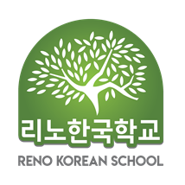
 |  |  | Student 1 |  |  |  | Student 2
Student | Name |  | Korean |  |  |  | Korean
Student |  |  | English |  |  |  | English
Student | DOB
Student | Grade / Sex |  |  |  |  | M □ |  |  | M □
Student |  |  |  |  |  | F □ |  |  | F □
Parents | Father | Name |  |  |  |  | Cell Phone
Parents | Father | E-mail
Parents | Mother | Name |  |  |  |  | Cell Phone
Parents | Mother | E-mail
Parents | Address
Photo /Video consent |  |  |  | I GIVE my permission to Reno Korean School to use photographs and video of my child without compensation on the school’s public web site.
 |  |  |  | I DO NOT want photos and video images of my child used on the school’s public web site.
Allergy & Specialty
Your child's Korean Level
Reno Korean School  Early registration: $150 / Semester |  |  | * Tuition(Semester): 1st Child $160, 2nd Child $150  (New student : $ 20 admission fee / $ 20 for snacks )  * Check Payable to : Reno Korean School  * Venmo : @ RENOKOREANSCHOOL  * Zelle : renokoreanschool@gmail.com  * Contact : Director, Michelle Yim (775 -232-7423 )  * E-mail : renokoreanschool@gmail.com

리노 한국학교(Reno Korean School) www.renokoreanschool.org
Signature : Date :

